**USER MANUAL**

User manual is a document which shows the user about the implementation of the application without any help. It is a type of guide for the user**.**

The traffic modeling system is a simulation system through which different types of road would be attached to simulate the behavior of traffic. There are several components like roundabout, 2-way road, 4-way, signals, and T-junction so that they would act as network of roads. To start the simulation, user need to input some parameters to run the application.

1. Once the user downloads and runs the application there will be popup showing landings of the each road which is set to the default values.

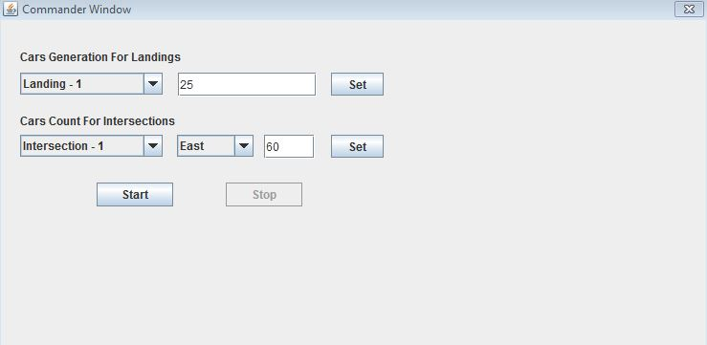

In the above window there are two inputs Fist one is cars generated for landing and the second one is cars count at the intersection.

1. For every landing 25 is given as the basic default input for each and every landing, there are 8 landings in the 2-D layout.
2. After giving the values the user has to set in order to set the parameters to generate the cars at the landings.

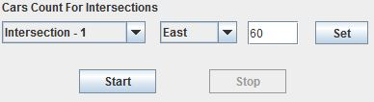

In the above figure cars count at every intersection is given as input on clicking the down arrow present at the intersection.

1. There exists directions East, West, North, South where the default 60 cars are set as the input parameter. If the user has to change he can change his values as he wants and click on set.
2. Once the user has done with setting the parameters click on the start button which will redirect to the simulation page.

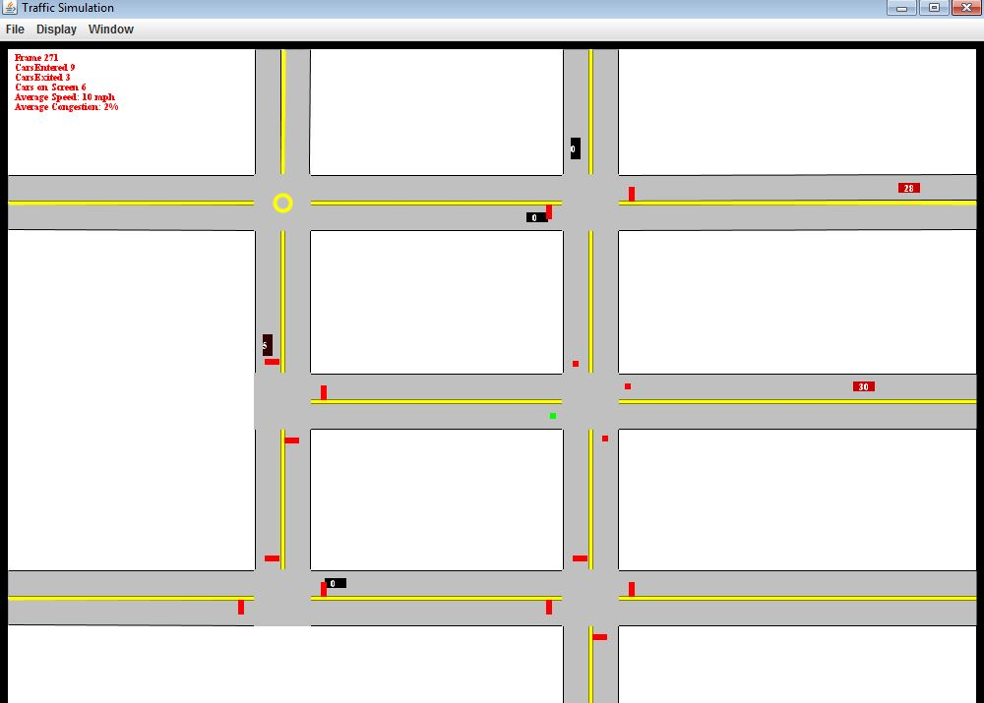

1. On the simulation page user will see a 2-D layout that has appeared and cars moving accordingly with the inputs given by the user.
2. Use can stop the application and at any point of time by clicking on the stop button on the application and restart it again.

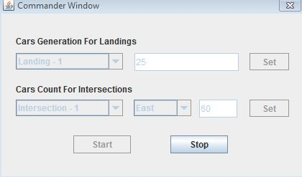

1. Information regarding the simulation is displayed on the top left part of the simulation page.

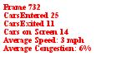

1. User can wait until the completion of the simulation to check the moving of the cars in all directions.
2. If the user clicks on the display, user can change the car speed accordingly by his wish on selecting the speed options of the car..



1. On the window there is a check box showing that whether we want the commander or not.
2. Finally user can stop the application after his simulation was completed.